**Phase 5**

**Lesson 3**

**Policies and Permissions**

Steps:

1. Creating a bucket

2. Adding policies

Step: 1 creating a bucket

* Create a new bucket in which we want to add policy with all default settings.

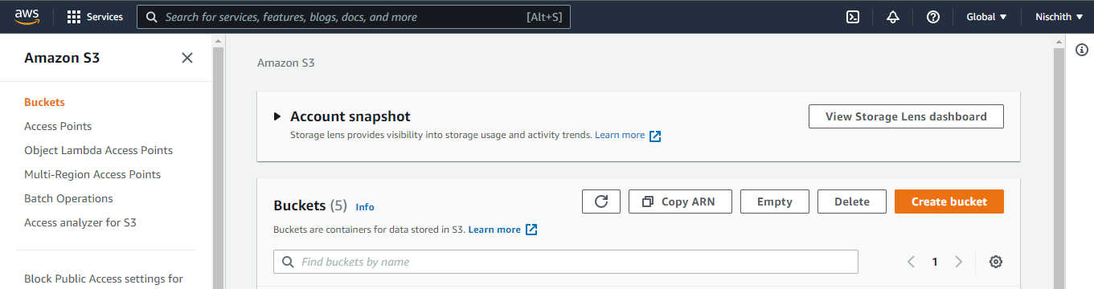

* Click on the Permission section.
* Go to Bucket Policy.
* It will open the console where you can add policy.

**Step 2:** Adding policies

* Click on the Policy Generator.

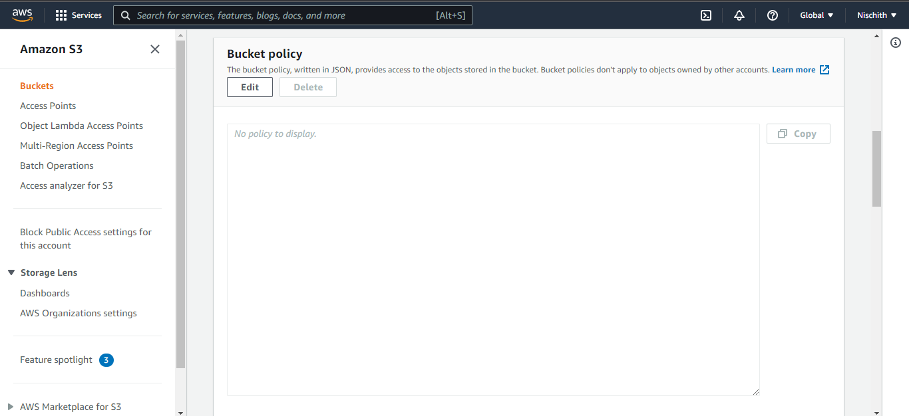

* Select the type of policy and services required.

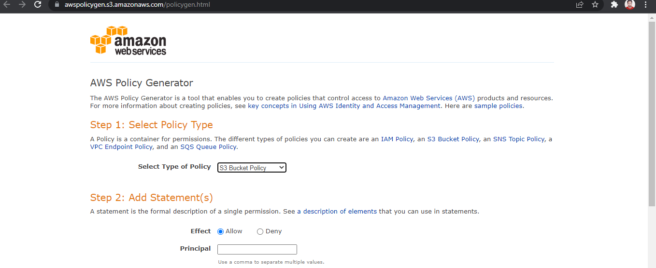

* Add ARN for S3 to add the policy.

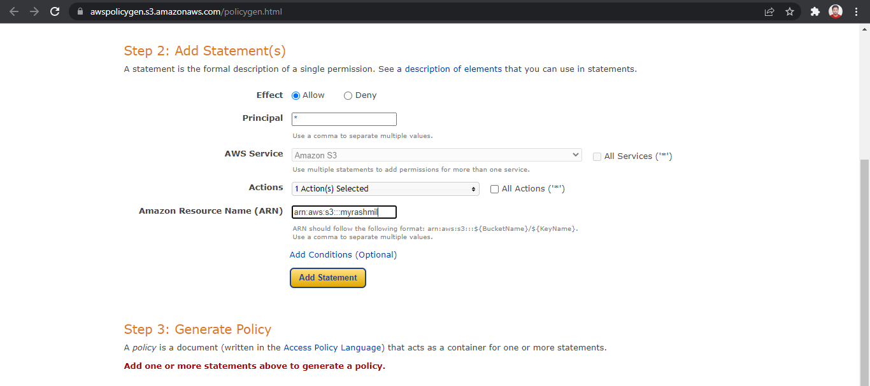

* Click on policy generator to create the JSON of the policy.

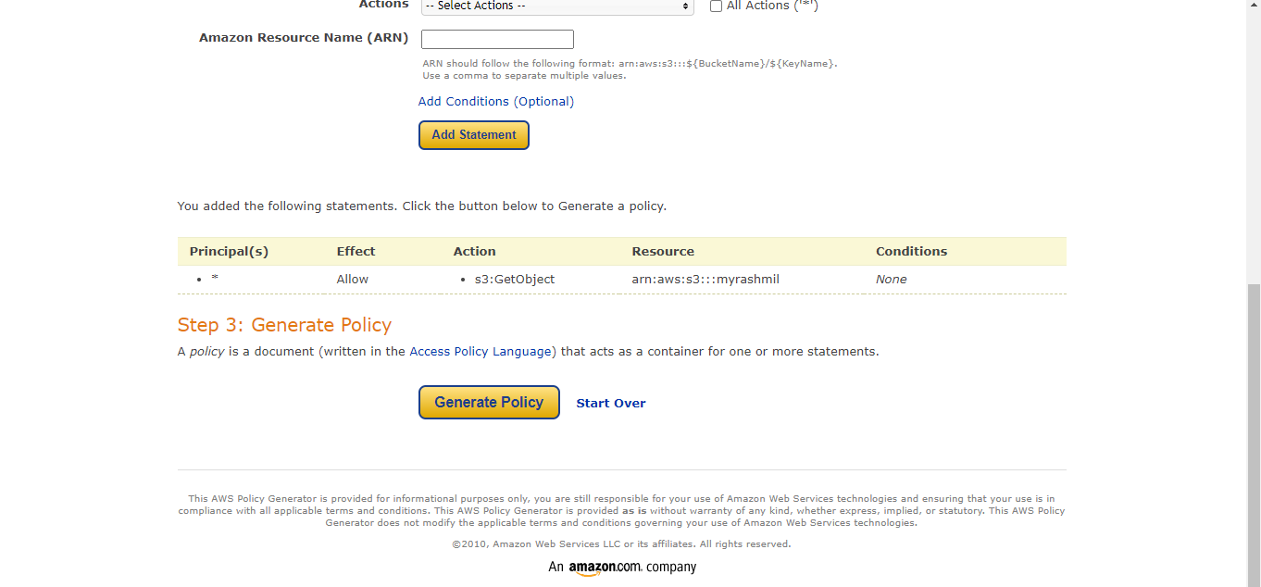

* Copy the generated JSON.

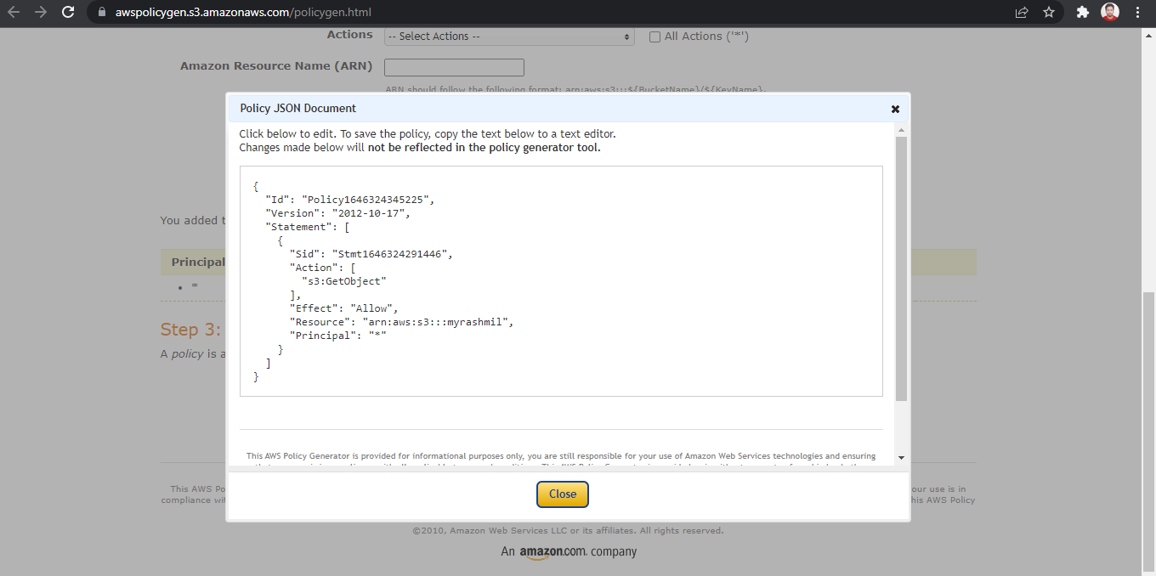

* Paste the JSON in the policy console of bucket and click on *Save*.

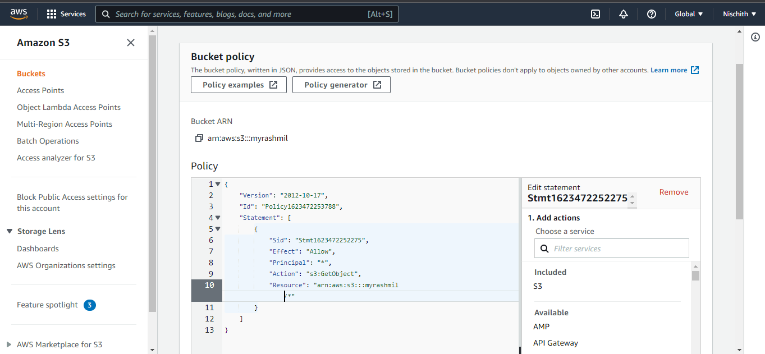

Now bucket is public

